Chapter 3 – Strings

The string is a data type in Python.

A string is a sequence of characters enclosed in quotes.

We can primarily write a string in three ways:

Single quoted strings : a = ‘harry’

Double quoted strings : b = “harry”

Triple quoted strings : c = ‘’’ harry ‘’’

String Slicing:

A string in Python can be sliced for getting a part of the string.

Consider the following string:

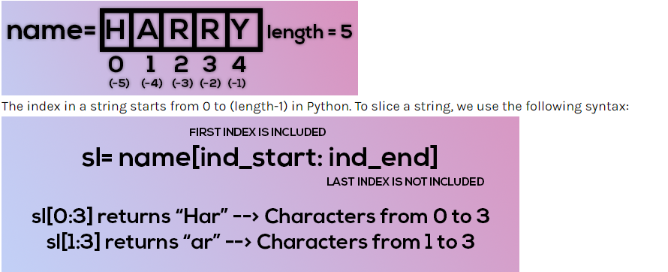

**Negative Indices:**Negative indices can also be used as shown in the figure above. -1 corresponds to the (length-1) index, -2 to (length-2).

**Slicing with skip value**

We can provide a skip value as a part of our slice like this:

word = “amazing”

word[1:6:2] # It will return ’mzn’

Copy

**Other advanced slicing techniques**

word = ‘amazing’

word[:7] or word[0:7] #It will return ‘amazing’

word[0:] or word[0:7] #It will return ‘amazing’

Copy

**String Functions**

Some of the most used functions to perform operations on or manipulate strings are:

1. **len() function :**It returns the length of the string.

len(‘harry’) #Returns 5

Copy

1. **endswith(“rry”) :**This function tells whether the variable string ends with the string “rry” or not. If string is “harry”, it returns for “rry” since harry ends with rry.
2. **count(“c”) :**It counts the total number of occurrences of any character.
3. **capitalize() :**This function capitalizes the first character of a given string.
4. **find(word) :**This function finds a word and returns the index of first occurrence of that word in the string.
5. **replace(oldword, newword)** : This function replaces the old word with the new word in the entire string.

**Escape Sequence Characters:**

Sequence of characters after backslash ‘\’ [Escape Sequence Characters]

Escape Sequence Characters comprises of more than one character but represents one character when used within the string.

Examples: \n (new line), \t (tab), \’ (single quote), \\ (backslash), etc.

1. Write a Python program to display a user-entered name followed by Good Afternoon using input() function.
2. Write a program to fill in a letter template given below with name and date.

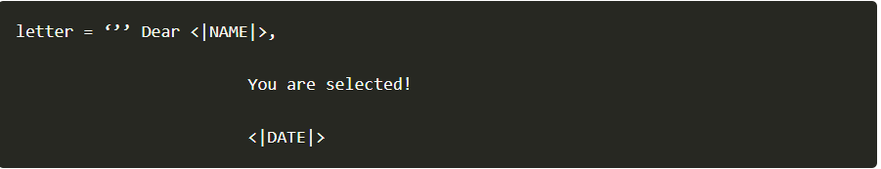

1. Write a program to detect double spaces in a string.
2. Replace the double spaces from problem 3 with single spaces.
3. Write a program to format the following letter using escape sequence characters.

letter = “Dear Harry, This Python course in nice. Thanks!!”